Elementary Lesson Plan
Grade:6_ Subject: Health Time-frame: 60 minutes
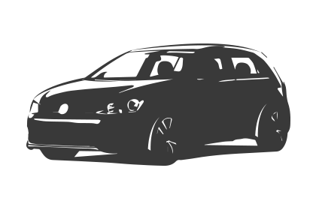Driving Question: What is a healthy body image?
Learning Targets: Creating a positive body image

GCO: Healthy Self
1.7- Describe the role of physical activity and healthy eating in maintaining healthy weight and preventing chronic disease.
GCO: Healthy Community:
3.2- Take age-appropriate action to present mental health issues faced among school-aged children in order to reduce the stigma that is often attached to mental health disorders. (anorexia/bulimia)
3.3- Respond to advertising of and communication about the use of alcohol, tobacco, gambling, caffeine, medicines, food, and natural/alternative health products and communicate these ideas within the school community.

Language Arts:
GCO 3- Students will be able to interact with sensitivity and respect, considering the situation, audience and purpose.
SCO’s: 3.1, 3.2, and 3.3
GCO 9- Students will be expected to use writing and other forms of representation to explore, clarify, and reflect on their thoughts, feelings, experiences, and learnings; and to use their imaginations.
SCO’s: 8.1, 8.2, 8.3
GCO 9- Students will be expected to create texts collaboratively and independently, using a variety of forms for a range of audiences and purposes.
SCO’s: 9.1, 9.2, 9.3

Connection to school improvement
Goal: Our students will demonstrate improvement in the area of writing with a focus on ideas, organization, language use and conventions. Students will be brainstorming ideas of their “best features” using a mind-map format.

Resources: Provide links to needed online resources, screen casts, files, rubrics, assessments etc.
- Dove Real Beauty Video
- Handout: Sketch Your Body (See Appendix 1)
- Example of Body Image Sketch (See Appendix 2)
- Calculating BMI (Body Mass Index) in teens: http://www.dietitians.ca/Your-Health/Assess-Yourself/Assess-Your-BMI/BMI-Children.aspx
- 4 x 6 blank paper for “Best Features”
- set of 25 mini mirrors and 1 full length mirror
- View Camera
- Ipads/computers
- Poll Everywhere login for exit ticket responses https://www.polleverywhere.com/

Adaptations (Child Specific):
- Some students have difficulty identifying body parts. Provide specific ideas for students to help identify features. For example: What about your eyes, cheeks, neck, waistline, thighs, calves?
- Provide a 4x6 sheet template for “best features”.

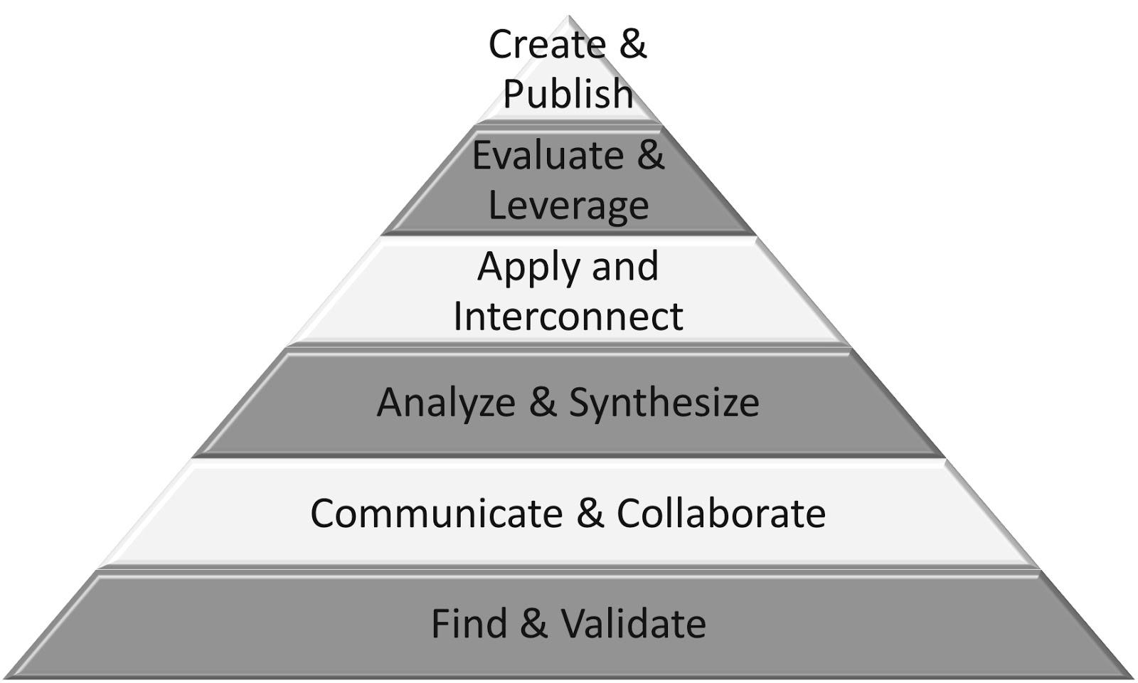
Part 1: Introduction:(usually 5 - 10 min. max)
Analyse
Apply
Communicate

Connection  Introduction:  - This is an introduction into a new unit in Health on healthy body image and creating and maintaining a healthy self.  Reflecting on prior teaching:  - We covered nutrition last term and discussed healthy relationships. | Teacher Script:  - Ask the students to think about and analyse what they look like such as their body shapes, by using the mini mirrors and the floor length mirror provided.  - Ask: What are some ways to keep ourselves healthy? How does this connect with our body image?
(Notes:)

Part 2: (approx. 5 min.)
Evaluate
Interconnect
Communicate

Explicit Teaching Teacher models/demonstrates  Explain to the class that they will be drawing a sketch of their own bodies. Show the example of what I drew for my own body shape and I shared it with the class. Let them know that this is not a drawing lesson and I will not be assessing their drawing skills but stick figures are not accepted. Discuss the parts of my body that I don’t love. | Teacher Script:  - This is probably going to be a very difficult task to complete. Analysing our own bodies are not something we do often. You might feel awkward or self-conscience but that is normal.  - Just try to be the most honest with your analysis as you can as you sketch yourself.
(Notes:)
For the entire class to view the example sketch that you have, you could view it on the viewcamera or take a picture of it and view it on the big board.
Part 3: (approx. 20 min.)

Independent/Groups  Practice/Conference focus:  Name the skill/strategy from the explicit teaching.  Students try it independently | Teacher Script:  Today and every day…  When working today, use this strategy when…  When working today, remember…
(Notes:)
Hand out the worksheet titled “Body Image”. Ask students to reflect on their image and draw what they believe to be their own body shapes. Try to fill the full length of the paper so the picture is large enough to see. Inform students that this is an outline of their bodies and they are not to include specific private parts but try to be as honest as they can when drawing their own image. They do not need to color in the sketch.

Part 4: 10 minutes
Communicate and Collaborate
Analyze
Interconnect
Time to Share  Will I use share time as…  -a mini-lesson reinforcement?  -a problem solving opportunity  -an opportunity for descriptive feedback  -an opportunity for assessment  What will it look like?  - Whole class  - Partner  - Small group | Teacher Script:  - One thing I’d like you to talk with your partner about while you share are the features you love about yourself.  - While you are sharing, I will be looking for honest answers and try to explain why you love each feature.
(Notes:) Following the sketches, students will be put into groups of 4 or 5 and they are then asked to share their drawings with the group but they must highlight the things they LOVE about their bodies. This tends to be more challenging than drawing themselves. People are often quick to identify what they don’t like but this exercise is for students to become more comfortable identifying what they like about themselves and sharing that with their peers.
As a peer, you are to provide complements to each person in your group as they highlight their sketches. Be honest and don’t force a compliment.

Part 4: 5-7 minutes
Collaborate
Apply and Interconnect
Evaluate

Guided Practice  How will students participate and practice what they have just learned? | Teacher Script:  Turn and talk to your partner about…  Go into your notebook and…  Work with a partner and…
(Notes:) Students watch a short video from Dove Soap titled Real Beauty Sketches: You’re more beautiful than you think. Discuss what they thought about the video. Do they view themselves differently now?
Show them the statistics of healthy body weight and height for students their age so they can understand that they are still growing and their bodies are in transition as they begin going through puberty.

Part 5: (usually 5-10 min.)
Create and Publish
Analyze
Evaluate
Communicate and Collaborate
Independent/Groups  Practice/Conference focus:  Name the skill/strategy from the explicit teaching.  Students try it independently | Teacher Script:  Today and every day…  When working today, use this strategy when…  When working today, remember…
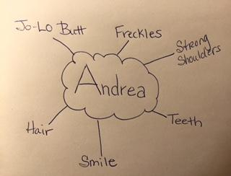
Notes: Hand out the 4x6 sheet of paper to each student and have them write their name in the center of the paper. Then they are to create a web around their name with all of their best features. For example:
After they completed the Best Features paper, ask them to identify the features that they can change and the features they cannot change. Discuss.
Ask the students how they felt about doing this exercise. What have they learned?
Students will login to a program called Poll Everywhere on the computers or ipads to provide their responses.

Next Steps: (Include parts or portions of the lesson that have not been completed.)

For homework, students were asked to browse through magazines to bring in a picture with a male or female model that they believe is an example of “true beauty”. This will lead into the next health class where we will be focusing on real and unreal images in the media.

APPENDIX 1:
BODY IMAGE SKETCH Name: _____________________

Directions: You are asked to draw a picture of your body in the box below. Make sure it is big enough to take up the whole page. It doesn’t have to be an art project, but do not draw a stick figure. On the separate piece of paper provided, I want you to list all the things you like, love and appreciate about your body.

APPENDIX 2:
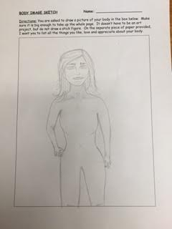
Body Image Sketch Example:

