Elementary Lesson Plan Template:
Grade:6 Subject: Social Studies Timeframe: 2-60 minute classesDriving Question: How do the reasons for migration relate to the Syrian refugees entering Canada?
Learning Targets:
World Cultures:
SCO 6.1.4: Identify and explain factors that are creating a more global
culture around the world.
Global Issues:
SCO 6.5.1, 6.5.2, 6.5.3

Resources: Provide links to needed online resources, screencasts, files, rubrics, assessments etc.
- Culture Quest by Angus Scully textbooks pages 48-53
- computers and posterboard (if selected as option for presentation)
- Login to Poll Everywhere to display student responses
- Slideshow on Push and Pull factors
- Video on Refugees Entering Canada for the first time
- Poster Rubric
- Websites to visit:
1. Syrian Refugees In Canada: Here's What We've Done Since 2012: http://www.huffingtonpost.ca/2015/12/31/a-chronology-of-canada-s-response-to-the-syrian-refugee-crisis-since-2012_n_8900468.html
2. NS Refugee Response http://novascotia.ca/refugeeresponse/
3. Canada Immigration: http://www.cic.gc.ca/english/refugees/outside/index.asp

Adaptations (Child Specific):
Create groupings that have a variety of skills and learning levels.
Provide a graphic organizer for students to find and validate the information.
Offer one-on-one support to discuss the topic in more child-friendly language.
Allow the content to be read through Kurzweil, assisted technology that turns text to speech.

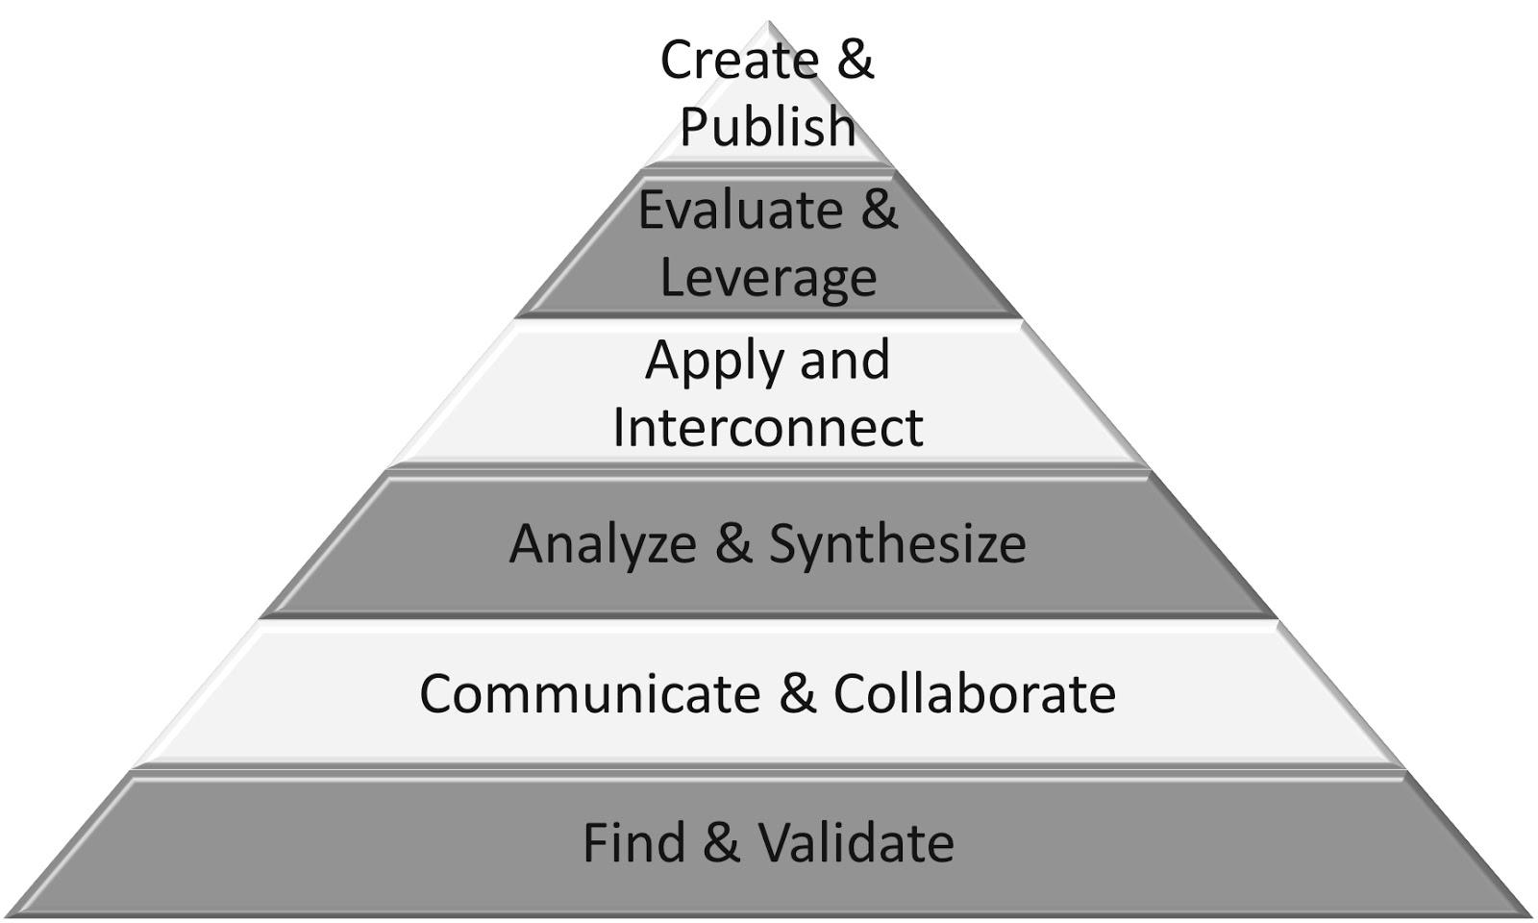
Part 1:
- Find and Validate
- Interconnect
- Analyze and Synthesize
- Communicate

Connection  Introduction: What do you know about the Syrian Refugess coming to Canada? To Halifax?  Reflecting on prior teaching: Connecting world cultures. | Teacher Script:  Yesterday we talked about…  What connection …  What do we already know...
(Notes:)
Using the web-based site Poll Everywhere, students login and give their response to the question: What do you know about the Syrian Refugees coming into Canada? This is to gain an understanding of what the students already know about the issue.
Explicit Teaching Teacher models/demonstrates  What is my purpose considering the needs of my students?  Discuss: What would you take with you if you were forced to leave your house?  Discuss: Push and Pull factors of migration.  Show Slide Show on Push and Pull factors. | Teacher Script:  If I had to leave my home to move to another country...I would bring items that were light and easy to carry such as photographs, and special documents.
(Notes:)
As a class, read over pages 48-53 in the CultureQuest textbook for background information. We are in a position where we can connect real current events with the curriculum we are teaching. With the Syrian Refugee crisis, Canada is opening its immigration act to accept 25 000 refugees in 2016. Halifax has already received a number of refugees into our city and the push is to help support these families. What would they need to survive in Halifax? Direct students to view the official Government website on NS refugees. http://novascotia.ca/refugeeresponse/
Students explore the Canadian Immigration site to discover what a refugee needs to qualify to enter Canada. http://www.cic.gc.ca/english/refugees/outside/index.asp
Guided Practice  How will students participate and practice what they have just learned? | Teacher Script:  Turn and talk to your partner about…  Go into your notebook and…  Work with a partner and…
(Notes:)
Identify the five specific reasons for migration into Canada:
- The Brain Drain
- United Nations High Commissioner for Refugees
- Canada’s Immigration Act
- People-smuggling
- Census of Canada
Create 5 groups of students. Assign one topic per group to research the who, what, where, why, how of each topic. How do these topics of migration relate to current situation of the refugee crisis today?
Using a method of choice, students will demonstrate their learning by publishing their findings. Suggestions as a medium: powerpoint, piccollage.com, imovie, poster board, etc.
Part 2: 30 minutes
- Communicate and Collaborate
- Apply and Interconnect
- Create and Publish

Time to Share  Will I use share time as…  -a mini-lesson reinforcement?  -a problem solving opportunity  -an opportunity for descriptive feedback  -an opportunity for assessment  What will it look like?  - Whole class  - Partner  - Small group | Teacher Script:  - Something I noticed today…  - Today we learned…  - Student name will share his/her learning…  - Student name will share a connection to his/her learning…  - One thing I’d like you to talk with your partner about while you share…  - While you are sharing, I will be looking for…
(Notes:)
Allow students 10 minutes at the beginning of the second class for students to meet in their groups to organize and finalize their presentations. Each presentation is 5-7 minutes long with additional minutes for classroom feedback.
Exit ticket: What is the most interesting piece of information you learned from this exercise?

Next Steps: (Include parts or portions of the lesson that have not been completed.)
Community Connection: Identifying ways that the students themselves could help to support the refugees coming to Halifax. What could they do to support refugee students?

