Elementary Lesson Plan Template
Grade:6 Subject: Language Arts Time frame: _2- 60 minute classes + presentations
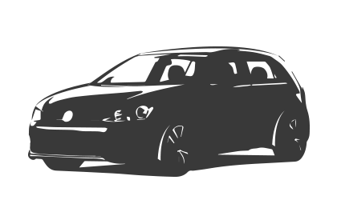Driving Question: How will understanding non-fiction text features, improve your comprehension skills?
Learning Targets:

Speaking-GCO 1: Students will speak and listen to explore, clarify, extend, and reflect on their thoughts, ideas, feelings and experiences.
SCO's: 1.1, 1.2, 1.3

Reading: GCO 7: Students will be expected to respond critically to a range of texts, applying their knowledge of language, form and genre.
SCO's: 7.1, 7.2, 7.3

Connection to school improvement
Goal: Analyzing and Synthesizing information from non-fiction text to develop ideas and strengthen their presentation skills without relying on reading directly from text or written notes.

Resources: Provide links to needed online resources, screencasts, files, rubrics, assessments etc.
*Elements of Non-fiction Text information sheet (1. sheet. 2. divided up as features and purposes and put into envelopes)
*Non-fiction Book Talk Purpose Sheet
*A variety of non-fiction texts for students to choose one from. I used the “X-Zone” books.
*Ipads
*Screencast- How to do a Non-Fiction Book Talk
*Packages of Post-it stickies to hand out to each student.
*Freshgrade app- to record evidence of their presentation and share it to parents on their online student portfolios.
*Presentation Rubric

Adaptations (Child Specific):
- Provide a rubric with limited number of text features expected to present
- Allow that student to create a script for their presentation in a numbered order for organization purposes.

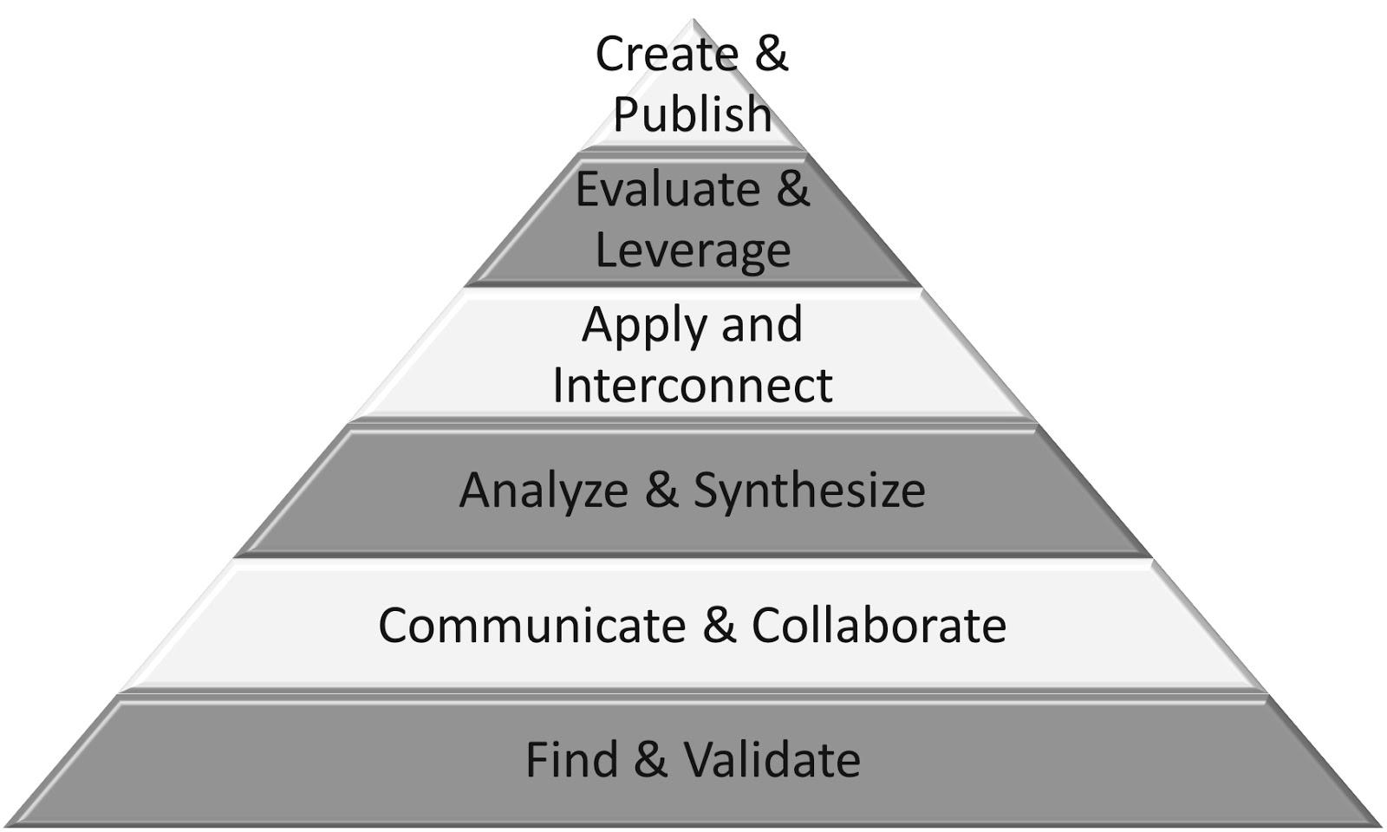
Part 1: (usually 10 - 15 min. max)
- Communicate and Collaborate
- Validate
- Analyze
- Apply and Interconnect

Connection  Introduction: Get the students to compare the features of fiction versus non-fiction texts using prior knowledge, and record on the board.  Reflecting on prior teaching: Students just completed a novel study in class so review the elements of a story. (Hook in the intro, rising action- middle, climax, falling action, conclusion- end, setting, characters) | Teacher Script:  Ask: What is the difference between fiction and non-fiction texts? And can they provide examples of both texts?
(Notes:) Following the brainstorming session on the board, hand out the “elements of a non-fiction text” cut up into strips to each pair of students. In their pairs, they must collaborate together to match the text feature to its purpose. They have limited time to complete. Once all matched up, they will use the Ipads to take a picture of their work and compare that to a group next to them and discuss if something needs to be re-positioned. At the end, hand out the full sheet to each student as a guide.
Explicit Teaching Teacher models/demonstrates  What is my purpose considering the needs of my students?  To teach students to recognize and apply the features of a non-fiction text to help make meaning from the text through a book talk presentation. | Teacher Script:  Watch me as I… present my example book. You will need to read through your chosen book multiple times to practice the material. This will improve your delivery of the content.  I want you to notice how I… do not read directly from the book. I refer to the text features used but also discuss the content of the book. I will become the expert on this book and will only rely on stickies to present my book.
(Notes:)
I will model a presentation of a non-fiction text book to the class, while focusing on the features and content I am encouraging from my students. The purpose of this was a follow-up from previous presentations where my students read directly from written notes and had little or no engagement with the audience. I saw this as a way to teach students what is necessary to conduct a proper presentation.
Guided Practice  How will students participate and practice what they have just learned? | Teacher Script:  Go into your notebook and…  Work with a partner and…
(Notes:)
Students will review the Elements of a non-fiction text from the handout. Students will be given a selection of “X-Zone” non-fiction books to choose one of interest for the Book Talk Presentations. This will help to put their new gained knowledge of non-fiction to practical use. Hand out the expectations sheet for this activity titled Non-Fiction Book Talk Purpose sheet (See resources). Show the screencast of “How to do a Non-fiction Book Talk” (See resources).
Part 2:
- Evaluate
- Synthesize
- Communicate
- Create

Independent/Groups  Practice/Conference focus:  Name the skill/strategy from the explicit teaching.  Students try it independently | Teacher Script:  Today and every day over the next three days, you will rehearse your books independently and with a partner for practice.  When working today, really focus of developing your speaking skills to incorporate more eye contact.
(Notes:)
They were given the direction to read through their books the first time to get an overall understanding of the content. The second read-through they are asked to cut the Post-it stickies into strips and use them to mark the features and content they want to highlight in the text during their presentation. This will help with the organization of their presentation. The next read-through will be to practice developing their presentation skills. They will continue to practice their presentations with a peer over the next couple of days leading up to the presentation dates. (three days later)
Part 3: 5-7 minutes per student
- Communicate
- Create

Time to Share  - Presentations to class | Teacher Script:  - Today we will be great listeners to the presentations from our classmates.  - Be prepared to ask a question to the presenter that relates directly to the content in their book talk.
(Notes:)
Students will begin presentations. Each student was given a copy of the rubric in advance while preparing for their presentations. They will hand this back to me for assessment during their presentation. I will also use “Freshgrade” app to record a segment of their presentation along with a picture to share with their parent and include in portfolio.

Next Steps: (Include parts or portions of the lesson that have not been completed.)
Continue to highlight various text features while working in their textbooks or any kind of non-fiction texts in the future. Encourage students to select non-fiction texts during independent reading times.

